**What are Conditional Statements in Python?**

Conditional Statement in Python perform different computations or actions depending on whether a specific Boolean constraint evaluates to true or false. Conditional statements are handled by IF statements in Python.

**What is Python If Statement?**

Python if Statement is used for decision-making operations.

It contains a body of code which runs only when the condition given in the if statement is true.

If the condition is false, then the optional else statement runs which contains some code for the else

condition.

**If Statement** : It uses the **if** keyword, followed by the condition.

**Syntax:**

if condition:

#statement to execute if the condition is true

Below is the entire workflow of how if statements work:

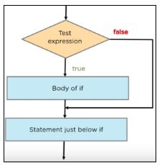

Indentation error

Python relies on indentation (whitespace at the beginning of a line) to define scope in the code. Other programming languages often use curly-brackets for this purpose.

Python if Statement Syntax:

if expression

Statement

**When we want to justify one condition while the other condition is not true, then you use Python if else statement.**

## ****if-else:-****

The if statement alone tells us that if a condition is true it will execute a block of statements and if the condition is false it won’t. But what if we want to do something else if the condition is false. Here comes the *else* statement. We can use the *else* statement with *if* statement to execute a block of code when the condition is false.

**Syntax**:

if (condition):

# Executes this block if

# condition is true

else:

# Executes this block if

# condition is false

**Python if…else Flowchart**

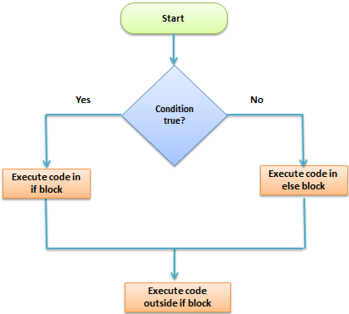

## Elif:-

The elif keyword is pythons way of saying "if the previous conditions were not true, then try this condition".

**Example:-**

a = 55  
b = 55  
if b > a:  
  print("b is greater than a")  
elif a == b:  
  print("a and b are equal")